**#6 Forms Practice Exercise**

Let's get some practice with forms, inputs, labels, and buttons! Write a simple form with the following inputs:

1. Username
   1. Text Input
   2. Should have placeholder text of 'username'
   3. Make sure to properly label the input (using id/for attributes)
2. Password
   1. Password Input
   2. Should have placeholder text of 'password'
   3. Make sure to properly label the input (using id/for attributes)
3. A Button
   1. With the inner text 'Register'

**I added in some <div> elements for spacing, but you don't need to:**

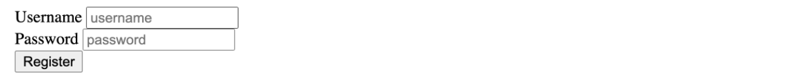

* [index.html](javascript:void(0))



1